WATCH OUT FOR !!!
AMITES
AQUIRING MINISTERS’ TEACHING SCHOOL
2027

For More Enquiries
Call: 08163776464 or 07039378043

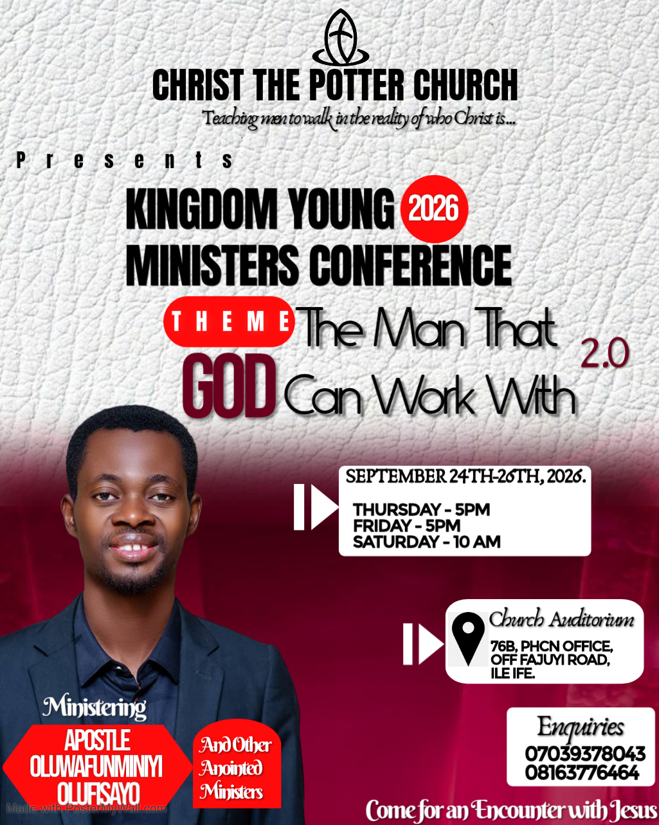

Welcome Address
Dear Beloved,
GLORY BE TO THE NAME OF THE LORD!!!
I want to use this medium to thank God for another year; for allowing us to witness another moment and season as ministers together, who are enlisted to work with God. It is a great privilege and honour to be called into the service of God, who is the Creator of the entire universe. We do not take this for granted, rather we esteem it. We thank God for what He did last year Ministers' Conference, whereby we examined the theme “the man that God will work with”. It is a great pleasure to know that God desires to work with every man. However, as good as this is, He will not just use us without us presenting ourselves according to His divine requirements and standards.
It is God’s desire that He should work with everybody, but this is something for which we have to qualify ourselves. Last year, we were able to look at the qualities that God desires to see in place before He can work with His servant: First, one must ascertain that there is a call of God to undertake one task or the other, in the light of the global assignment of what God is doing upon the face of the earth. We also examined that such a man must be a man who pleases God; a man who trembles at the Word of the Lord. He must be a man who fears the Lord. He must be a man who is jealous for God and His cause. He must be a man who savours the things of God more than the things of men.
By the special grace of God, we believe that the Lord is not done with us yet on this topic. I believe there is much more that He wants to dispense to us in order for us to become the man He can work with.
Also this year, we will examine part two of the same theme: “The Man That the Lord Will Work With.” And as we gather, we trust the Holy Spirit to take us further in the light of this theme and give us further insights into the requirements of what it takes for God to work with a man. I pray that the Lord will find us worthy in our days and generation to work with us.
So, in these three days, we trust the Lord will take us on a journey through His Word and His Spirit, to enlighten us more on what it requires for God to work with us. You know where Jesus said that” indeed the harvest is plentiful, but the labourers are few”. Though we may look at the face of the earth and say, yes, there are many ministers of God upon the face of the earth, but it is not
ANNOUNCEMENTS

Christ The Potter Churchis a place you need to always be for your divine training in Life and Destiny.

WORSHIP WITH US
Sunday Sunday service:8am
Tuesday School of prayer: 5pm
Thursday Revelational Hour: 5pm

The church operates a ministry Arm “Oluwafunminiyi Samson Olufisayo Ministries”

You can connect with us ONLINE via Facebook @CHRIST-THE-POTTER-CHURCH

Visit the Media Stand to invest in your Spirit Man, “For Man shall not live by bread alone but by every word that proceeds from the mouth of God”

AVAILABLE MESSAGES
- CULTIVATING THE HABIT OF SEEKING AND RECEIVING DIVINE HELP IN THE TIME OF NEED.
- THE LAW OF GOING LITTLE FURTHER .
- UNDERSTANDING PRAYER AND THE HINDERACE THAT CHOKE THE EFFECTIVENESS.
- CONFLICT IN MARRIAGE AND HOW DEAL WITH IT.
- FAER IS NOT A CHRISTIAN VIRTUE.
- WHAT IS THE MESS HAVE YOU TRIED JESUS?
- FATHERING
- CONSECRATION

everyone that God takes pleasure in working with to execute His divine counsel and agenda on this side of heaven.
And it is high time, in our generation, to begin to major on what God works with and avoid every other thing that can stand as a distraction, or things upon which God does not choose to place His power, His anointing, and His grace in order to work with them.
In every generation of men who are called, God uses them mightily to demonstrate His glory. But those men qualify themselves by aligning with what God can work with.
God is also counting on us, as ministers, to begin to align ourselves with Him in order to reset us, and in order to use us mightily in our own days and generations.
I believe that in these three days, the Holy Ghost will minister to us, impart us, and make us more effective in whatsoever God has called us to execute for His name and for His kingdom, in the name of Jesus. I want us to be receptive to receive what God has ordained for us.
You are welcome once again, and God bless every one of you.
Yours-in-the-Vine
Apostle Oluwafunminiyi Olufisayo

MINISTER’S PROFILE

Apostle OluwafunminiyiOlufisayois an ordained minister of the gospel called and sent from God as a conference speaker and life trainer with an apostolic teaching and preaching mandate to teach men to walk in the reality of who Christ is. He is also passionate about seeing the order of God being established in the Church. His apostolic teaching has influenced, Inspired and transformed many lives in this Era.
He is the President of Oluwafunminiyi Samson OlufisayoMinistries and the set man of Christ The Potter Church.
He holds an Annual meeting tagged GATHERING OF THE EAGLES, a quarterly programme tagged REALISED DESTINY SUMMIT, REVELATION OF OUR SALVATION, and also two Annual Conference for Ministers tagged: JESUS AND HIS MEN CONFERENCE [JAHMEC] and KINGDOM YOUNG MINISTERS’ CONFERENCE [KYMC]. He also holds a Teaching School - ACQUIRING MINISTERS’ TEACHING SCHOOL (AMITES) for those who have perceived the Call of God and those who are involve in church work. All these are set to teach and impact men to align with the ultimate counsel of God for their lives. He is happily married to Rev. Mrs.OlamideOlufisayo who also serves with him in the Ministry. They reside in Ile-Ife, Osun State, Nigeria.

Schedule of Ministration
Date And Days | Morning Session | Evening Session
Thursday 24Th September |  | Apostle Oluwafunminiyi Olufisayo
Friday  25Th September |  | Apostle Oluwafunminiyi Olufisayo
Saturday 26Th September | Apostle Oluwafunminiyi Olufisayo
Programme of events
Thursday 24Th September 2026 Evening
5:00 pm - 5:10p.m. [10 mins.] Opening Prayers
5:10pm –5:30 p.m. [20 mins] shout of Praise
5:30pm – 5:55 p.m. [25 mins] Prayers and Supplication
5:55 pm – 6:00 p.m .[5 mins.] Introduction of The Minister
6:00 – 7:30 p.m. [1 hr 30 Mins] Word Ministration
Apostle.Oluwafunminiyi Olufisayo
7:30 – 7:35 p.m. [5 mins.] Offering and announcements.
Friday 25Th September 2026 Evening
5:00 pm - 5:10p.m. [10 mins.] Opening Prayers
5:10pm –5:30 p.m. [20 mins] shout of Praise
5:30pm – 5:55 p.m. [25 mins] Prayers and Supplication
5:55 pm – 6:00 p.m .[5 mins.] Introduction of The Minister
6:00 – 7:30 p.m. [1 hr 30 Mins] Word Ministration
Apostle.Oluwafunminiyi Olufisayo
7:30 – 7:35 p.m. [5 mins.] Offering and announcements.
Saturday 26Th September 2026 Morning
10:00 am – 10:10 a.m. [10 mins.] Opening Prayers
10:10 –10:40 a.m. [30 mins] shout of Praise
10:40 – 11:00 a.m. [20 mins] Prayers and Supplication
11:00 – 11:05 a.m. [10 mins.] Introduction of The Minister
11:05 a.m– 1:05 p.m. [2hrs ] Word Ministration
Apostle.Oluwafunminiyi Olufisayo

